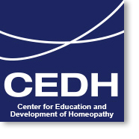

Training Course in Clinical Homeopathy

Join thousands of practitioners who have discovered the benefits of homeopathy in clinical practice
Register Now to Save Up to $800

Early bird discount ends October 10, 2019!

 | Top Reasons to Register  - Clinically relevant  - Easily integrated into daily practice  - Experienced educators  - Flexible schedule  - Lifetime registration | CANADA LOCATIONS  TORONTO, VANCOUVER, MONTREAL  Designed for MDs, RNs, NDs, RPHs, PAs and RMs the CEDH Clinical Homeopathy Training Course will help you integrate homeopathy into your daily practice. Taught by experienced physicians the course offers a flexible schedule with lifetime membership (with Full Enrollment) at ten convenient locations.

Visit: www.cedhusa.org
If you have any questions about CEDH courses or registration process, please contact us at 1-866-550-2334 or cedh@cedhusa.org

